Housing environment: a non-invasive stimulation affects cognition ability and synaptic plasticity via altering balance of excitatory/inhibitory receptors in mice hippocampus

Hui Wang¹, Xiaxia Xu¹, Jing Gao²,Tao Zhang¹*
¹College of Life Sciences and Key Laboratory of Bioactive Materials Ministry of Education, Nankai University, 300071 Tianjin, PR China
²School of Medicine, Nankai University, Tianjin 300071, PR China

Running title: Housing environment change E/I balance

* Corresponding author: Tao Zhang
Tel.: +86 22 23500237
E-mail address: zhangtao@nankai.edu.cn

Supplementary figures
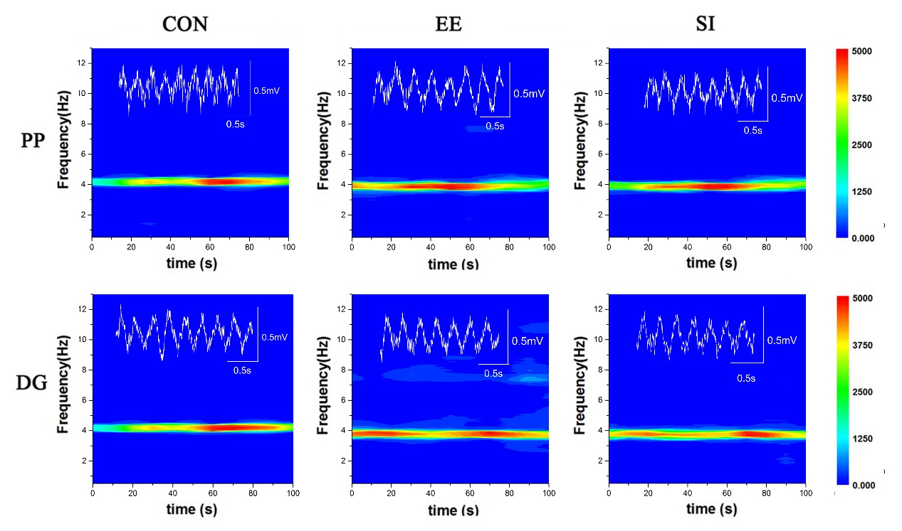
Fig.S1 Power spectral analysis in the three groups. a. Representative local field potential traces and corresponding power spectra in PP and DG regions in a mouse of the CON group. b. Representative local field potential traces and corresponding power spectra in PP and DG regions in a mouse of the EE group. c. Representative local field potential traces and corresponding power spectra in PP and DG regions in a mouse of the SI group.

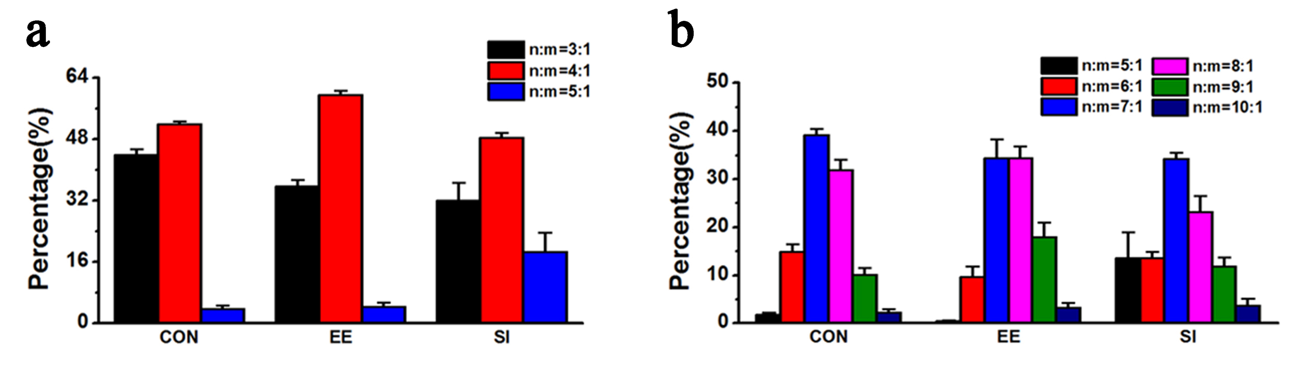
Fig.S2 The percent distribution of the peaks of three groups in PP alpha and gamma. a. The percent distribution of the peaks of three groups in PP alpha and LG. b. The weighted sum of phase synchronization strength of three groups in PP alpha and HG.

